Additional files

Reactors | SCOD before PTs (g/l) | SCOD after PTs (g/l)
Control | 3.92 | 5.10
FNA1 | 3.92 | 8.75
FNA2 | 3.92 | 10.35
FEN1 | 3.92 | 7.20
FEN2 | 3.92 | 11.32
FNA1+FEN1 | 3.92 | 12.95
FNA2+FEN2 | 3.92 | 17.75
FNA1+FEN2 | 3.92 | 16.80
FNA2+FEN1 | 3.92 | 13.21
Table 1-S. Soluble Chemical Oxygen Demand before and after pre-treatments (average of triplicate tests)
Table 2-S. Soluble protein before and after pre-treatments (average of triplicate tests)

Reactors | Soluble Protein before PTs (mg /L) | Soluble Protein After PTs (mg/L)
Control | 272 | 514
FNA1 | 272 | 1552
FNA2 | 272 | 1754
FEN1 | 272 | 1679
FEN2 | 272 | 1978
FNA1+FEN1 | 272 | 2502
FNA2+FEN2 | 272 | 2913
FNA1+FEN2 | 272 | 2687
FNA2+FEN1 | 272 | 2581
Table 3-S. Soluble polysaccharide before and after pre-treatments (average of triplicate tests):

Reactors | Soluble Polysaccharide before PTs (mg / L) | Soluble Polysaccharide After PTs (mg/L)
Control | 5845 | 6013
FNA1 | 5845 | 6886
FNA2 | 5845 | 6962
FEN1 | 5845 | 6776
FEN2 | 5845 | 6894
FNA1+FEN1 | 5845 | 7650
FNA2+FEN2 | 5845 | 7763
FNA1+FEN2 | 5845 | 7622
FNA2+FEN1 | 5845 | 7712

Table 4-S. Cumulative methane production during digestion process (average of triplicate tests)

Day | 1 | 5 | 10 | 15 | 20 | 25 | 30 | 35 | 40 | 44
Control | 15 | 85 | 145 | 178 | 191 | 198 | 203 | 207 | 209 | 209
FNA1 | 14 | 89 | 163 | 205 | 225 | 235 | 242 | 246 | 248 | 248
FNA2 | 15 | 87 | 166 | 222 | 243 | 251 | 257 | 261 | 262 | 263
FEN1 | 14 | 90 | 156 | 198 | 222 | 230 | 234 | 238 | 239 | 240
FEN2 | 16 | 93 | 172 | 217 | 237 | 251 | 257 | 261 | 262 | 263
FNA1+FEN1 | 16 | 91 | 170 | 224 | 270 | 289 | 296 | 298 | 300 | 301
FNA2+FEN2 | 14 | 90 | 181 | 240 | 290 | 327 | 341 | 349 | 354 | 355
FNA1+FEN2 | 15 | 90 | 158 | 216 | 264 | 308 | 328 | 334 | 337 | 337
FNA2+FEN1 | 16 | 86 | 163 | 229 | 287 | 318 | 323 | 325 | 328 | 329

Table 5-S. total solids during the digestion process (average of triplicate tests)

day | 0 | 5 | 10 | 15 | 20 | 25 | 30 | 35 | 40 | 44
Control | 34.3 | 32.9 | 27.0 | 23.2 | 22.5 | 21.5 | 21.2 | 19.8 | 19.7 | 19.7
FNA1 | 34.2 | 26.8 | 24.7 | 19.9 | 19.6 | 19.1 | 18.2 | 17.1 | 16.1 | 16.3
FNA2 | 34.2 | 25.5 | 23.5 | 17.3 | 16.3 | 15.9 | 15.8 | 15.5 | 15.1 | 14.9
FEN1 | 34.0 | 26.8 | 22.9 | 21.4 | 20.2 | 19.8 | 19.1 | 17.5 | 17.0 | 15.7
FEN2 | 33.9 | 27.7 | 21.6 | 21.0 | 19.9 | 17.7 | 17.4 | 15.8 | 15.7 | 12.9
FNA1+FEN1 | 33.9 | 27.1 | 21.2 | 20.0 | 18.9 | 17.7 | 17.5 | 14.9 | 13.6 | 13.4
FNA2+FEN2 | 33.8 | 27.6 | 22.3 | 20.2 | 18.6 | 14.5 | 12.6 | 11.5 | 11.0 | 10.4
FNA1+FEN2 | 33.9 | 26.3 | 22.8 | 19.8 | 17.4 | 16.3 | 14.6 | 13.8 | 13.2 | 12.6
FNA2+FEN1 | 33.9 | 25.1 | 23.1 | 18.1 | 15.3 | 14.9 | 14.8 | 14.6 | 13.4 | 13.3

Table 6-S. volatile solids during the digestion process (average of triplicate tests)

Day | 0 | 5 | 10 | 15 | 20 | 25 | 30 | 35 | 40 | 44
Control | 26.8 | 23.0 | 20.3 | 18.8 | 18.3 | 17.9 | 17.7 | 17.5 | 17.5 | 17.4
FNA1 | 24.6 | 20.9 | 17.9 | 16.2 | 15.3 | 14.9 | 14.7 | 14.5 | 14.4 | 14.4
FNA2 | 24.5 | 20.9 | 17.7 | 15.4 | 14.5 | 14.2 | 14.0 | 13.8 | 13.8 | 13.7
FEN1 | 25.1 | 21.5 | 18.8 | 17.1 | 16.2 | 15.8 | 15.7 | 15.5 | 15.4 | 15.4
FEN2 | 24.4 | 20.7 | 17.4 | 15.6 | 14.8 | 14.3 | 14.0 | 13.9 | 13.8 | 13.8
FNA1+FEN1 | 24.3 | 20.6 | 17.4 | 15.2 | 13.3 | 12.6 | 12.3 | 12.2 | 12.1 | 12.1
FNA2+FEN2 | 24.1 | 20.4 | 16.8 | 14.4 | 12.4 | 10.9 | 10.4 | 10.1 | 9.9 | 9.8
FNA1+FEN2 | 24.2 | 20.6 | 17.8 | 15.5 | 13.6 | 11.8 | 11.0 | 10.7 | 10.6 | 10.6
FNA2+FEN1 | 24.2 | 20.8 | 17.7 | 15.0 | 12.6 | 11.4 | 11.2 | 11.1 | 11.0 | 11.0

Fig 1-S. Bichemical methane potential system
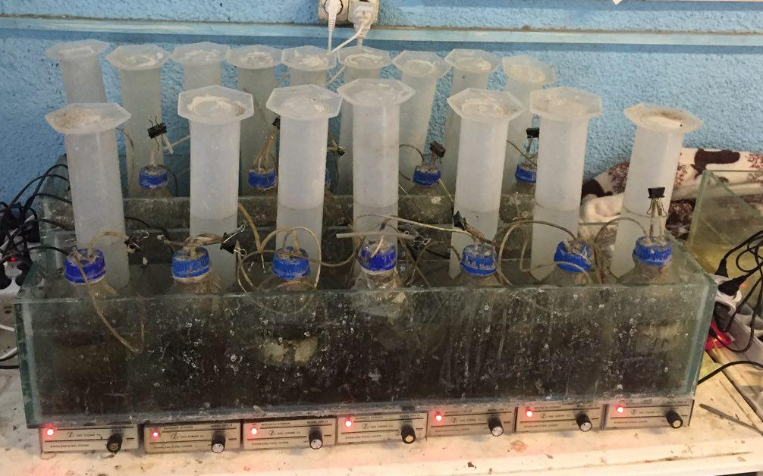

Fig 2-S. Soluble protein and polysaccharide measurements
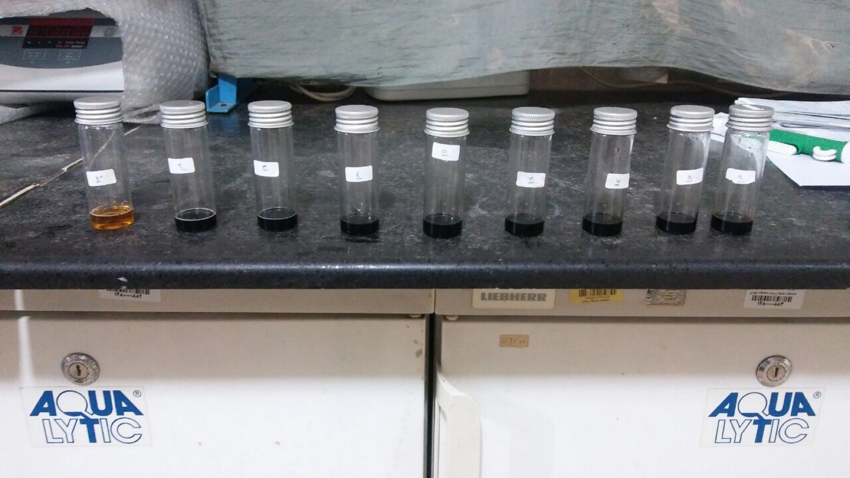

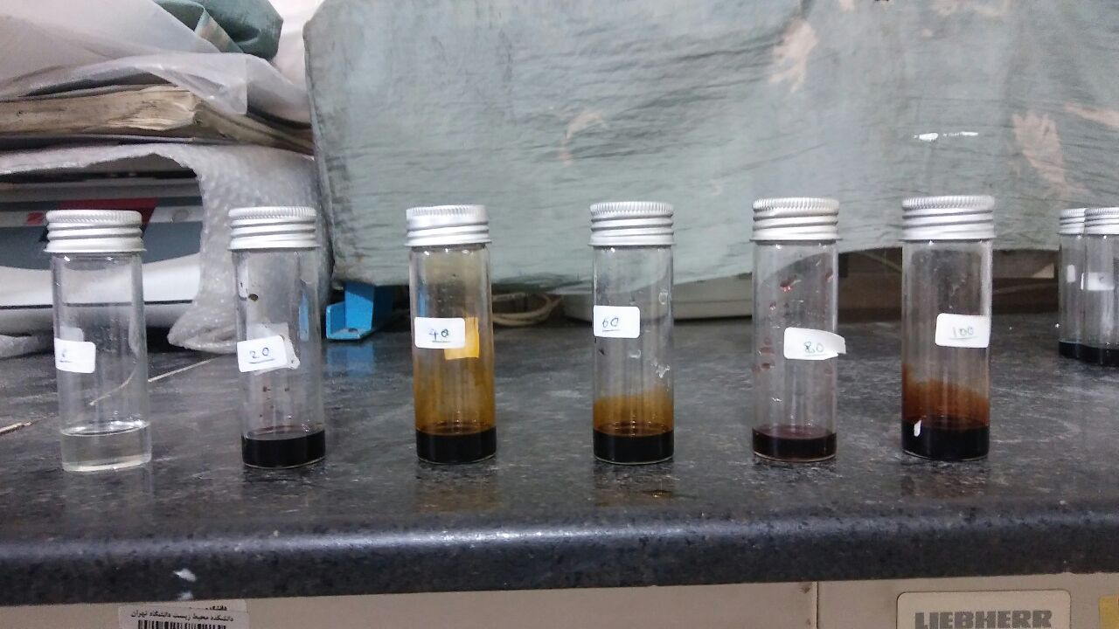
Fig 3-S. Gas chromatography analysis
